NAME: KAVITAPU SWARNA VARSHINI
REG.NO: 192324081
DATE: 14-07-2026

Write a python program for A* alogirthm
AIM: To write a Python program to implement the A* Search Algorithm for finding the shortest path between a start node and a goal node.
ALGORITHM:
- Represent the graph and assign heuristic values to each node.
- Initialize the start node with cost 0.
- Select the node with the lowest f(n) = g(n) + h(n) value.
- Update the path cost of neighboring nodes and continue searching.
- Stop when the goal node is reached and display the shortest path.
CODE:
graph = {
'A': [('B', 1), ('C', 3)],
'B': [('D', 3), ('E', 1)],
'C': [('F', 5)],
'D': [],
'E': [('G', 2)],
'F': [('G', 1)],
'G': []
}

h = {
'A': 5,
'B': 4,
'C': 4,
'D': 3,
'E': 2,
'F': 1,
'G': 0
}

open_list = [('A', 0)]
parent = {'A': None}
cost = {'A': 0}

while open_list:
open_list.sort(key=lambda x: x[1] + h[x[0]])
node, g = open_list.pop(0)

if node == 'G':
break

for n, w in graph[node]:
new_cost = cost[node] + w
if n not in cost or new_cost < cost[n]:
cost[n] = new_cost
parent[n] = node
open_list.append((n, new_cost))

path = []
node = 'G'
while node:
path.append(node)
node = parent[node]

print("Shortest Path:", path[::-1])
print("Total Cost:", cost['G'])
OUTPUT:
Shortest Path: ['A', 'B', 'E', 'G']
Total Cost: 4
IMAGE:
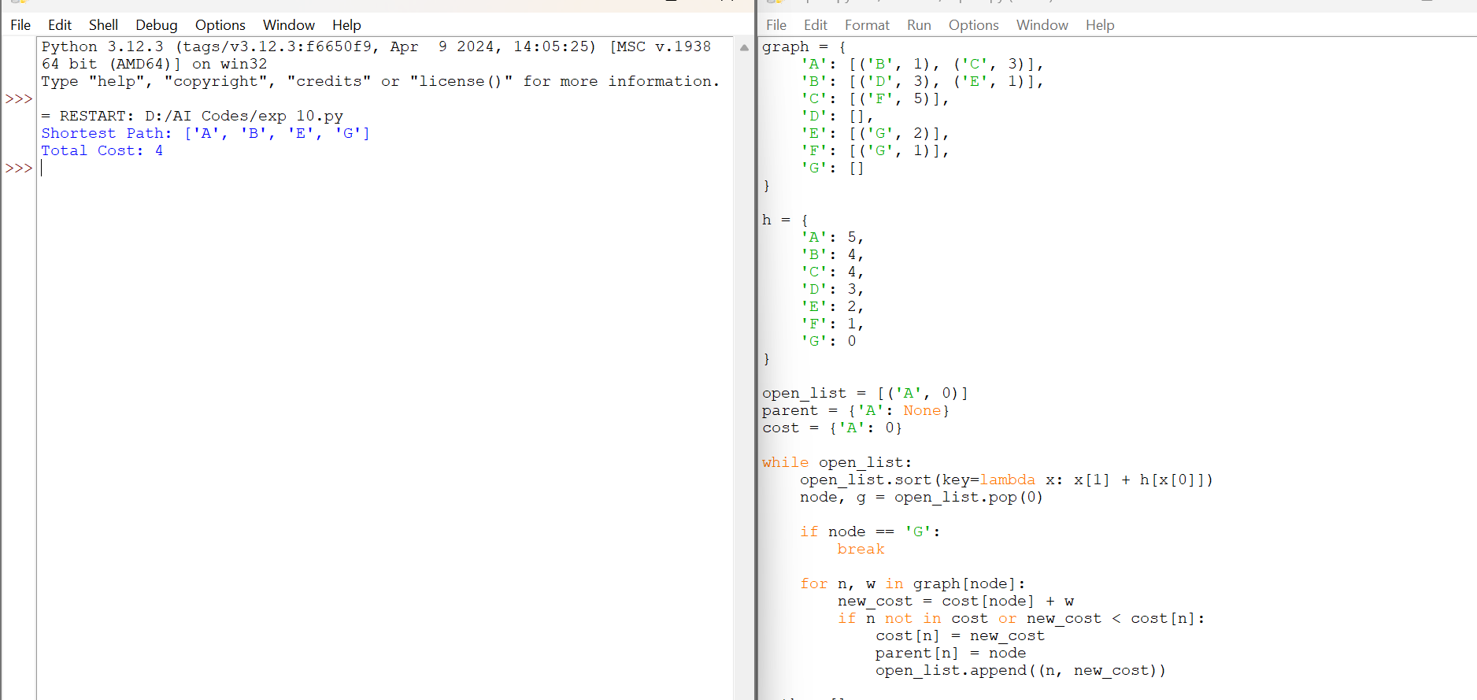

RESULT:
The Python program successfully implemented the A* Search Algorithm and found the shortest path from the start node to the goal node using the evaluation function f(n) = g(n) + h(n). The shortest path obtained is A → B → E → G with a total cost of 4.

